**More 'All About Money': Looking At The Past**

April 11, 2008

Elaine Meinel Supkis

Every few weeks, readers here ask questions that are really good. Yesterday, some questions were asked that are best answered by going deep into the archives of the newspapers in the deep past. So today, we get to read original articles from the New York Times circa 1913 to 1917. From the creation of the Federal Reserve to the First World War when this new banking system threw over all the controls and jumped all the hedges and ran out the wide open barn doors that were cleverly inserted into the Federal Reserve Banking Act by the compromises under Senate Banking Chair, Senator Glass.

[US Trade Deficit Shoots UPWARDS Despite Weak Dollar](http://elainemeinelsupkis.typepad.com/money_matters/2008/04/us-trade-defici.html)

*Hi Elaine,*

*Thanks for all of your great research.*

*Have a question for you:*

*In the process of operating our money system the Fed charges interest on U.S. debt, subtracts "fees and expenses", and then gives the rest back to the Treasury.*

*This isn't a law, this is done through a rule passed by the Board of Governor's which agrees to do this pass through.*

*My questions:  
Why does the Fed hand back hundreds of billions of dollars to the Treasury?*

*Does anyone regulate how much normal "fees and expenses" are?*

*Can the Fed decide at any time not to pass this interest money back to the Treasury?*

*Illuminating this rule would be a great addition to your column.*

*Keep up the great work*

*Posted by: Abelian | April 10, 2008 at 10:18 PM*

*\*\*\*\*\*\*\*\*\*\*\*\*\*\*\*\*\*\*\*\*\*\*\*\*\*\*\*\*\*\*\*\*\*\*\*\*\*\*\*\*\*\*\*\*\*\*\*\*\*\*\*\*\*  
I was wondering...*

*They are all talking about these money as if this is real. Why not let the funny papers written off already?*

*Isn't majority of these money just transaction upon transaction between the banks themselves with no connection to reality.*

*It's like me and my dog writing each other paper worth $20 million dollars and thinking we are billionaires at the end of the night.*

*my naive question: aside from subprime real estate and owing japanese Yen, what exactly do those several trillion dollar mean?*

*At least Enron was buying/speculating energy supply. They got something I can understand. but all those trillions of fancy papers?*

*What's so big deal about paying all those funny papers? All those sub prime houses couldn't possibly worth trillions of dollar. You can glaze downtown LA with gold with that much money, nevermind houses.*

*Posted by: Anthony | April 10, 2008 at 11:02 PM*

There are a number of fine websites that try to explain how our financial system works. There are many that explain how the Federal Reserve works. If one goes to the Federal Reserve looking for information, there are so many outright lies there, it is impossible to figure out what is really going on. They run the ultimate Cloaking Device. We can see the light shimmer around their space craft but we can't see them directly. But if we look into the telescope of history, we can see their previous incarnations and passages through time. This shows the bowsprit of this vast craft distorting space and time. There is this trick within Google now whereby I can use the right combination of numbers and letters to gain access to old newspapers. Using this, I can find interesting articles, sometimes it takes hours of hunting. Here is a collection of stories from the creation of the Federal Reserve to its first major action which was to create a ton of funny money to lend to Europe for WWI and the WWI aftermath:

[July 22, 1913](http://query.nytimes.com/gst/abstract.html?res=9D03E3DD163DE633A25751C2A9619C946296D6CF)

[PUT RESERVE NOTES ON A GOLD BASIS; House Democrats Also Decide to Place No Limit on Amount of Issue.](http://query.nytimes.com/gst/abstract.html?res=9D03E3DD163DE633A25751C2A9619C946296D6CF) [ELAINE: This unlimited Issue is their power to create funny money out of thin air without any interference from the Treasury.]

[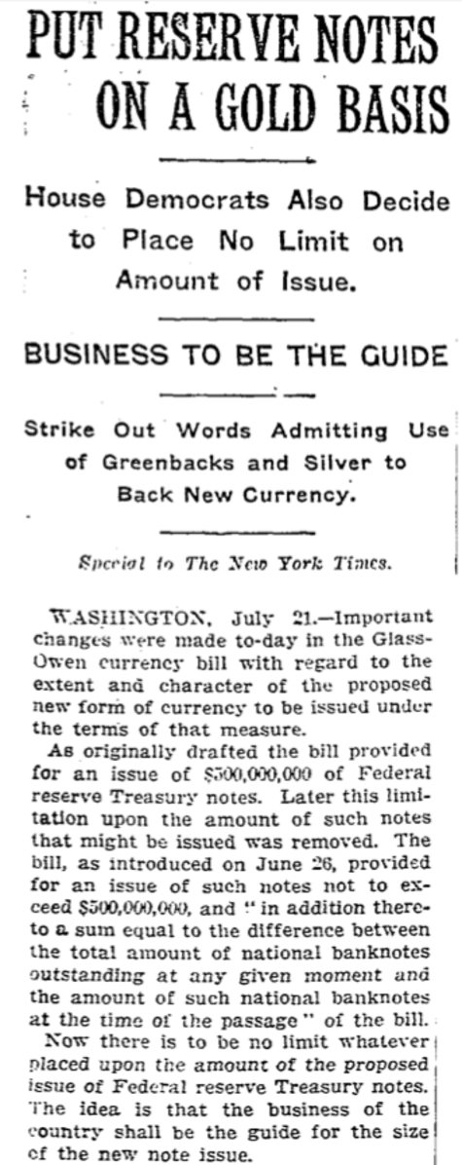](http://elainemeinelsupkis.typepad.com/.shared/image.html?/photos/uncategorized/2008/04/10/picture_23.png)  
[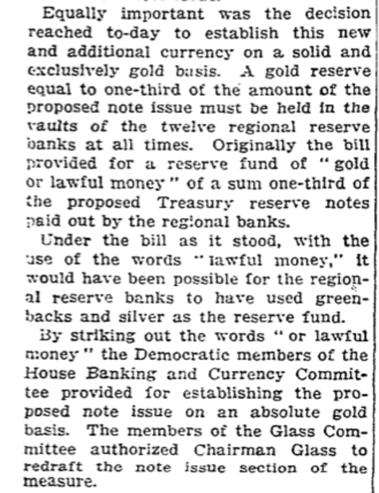](http://elainemeinelsupkis.typepad.com/.shared/image.html?/photos/uncategorized/2008/04/10/picture_24.png)

********************************************************

Back then, the long post-Civil War debate about Greenbacks, gold and silver were finally put to rest. The Federal Reserve would be based on gold only. But was given the great gift of being allowed to print infinite sums of paper money on the gold without any regard to limitations of any sort! This was a 'compromise' between the inflationists and the international traders. There was no simple constituency here. The people who grew cotton, for example, wanted good trade but the industrialists wanted tariff protections. We can plainly see today that when exporters of raw materials win the ideological war over 'free trade', we lose all our major industries.

Back then, the US industrial base was protected. They exported value-added goods. The raw material exporters who sold mineral and natural wealth as well as farm products wanted little or no trade controls. The people who wanted gold as the basis wanted to squeeze the commodity trades and that would then keep prices lower at home thanks to cheaper food and raw materials for manufacturing! This struggle for power was fought in the three ring circus of currency types and systems. An interesting way of doing it, by the way.

Note how this article above is about the issuing of $500 million in Treasury bills that would be handed over to the brand-new Federal Reserve. The people in the various trade industries that feared inflation insured there would be severe limitations on the creation of funny money by the independent Federal Reserve. No longer could they call the President for help. They were now trapped in a corner by their own bankers who did an interesting end run past the hulking defensive linebackers. Suddenly, in a Hail Mary pass that involved greasing a lot of palms in Washington, DC, the severe limitations placed on money making were suddenly terminated! Isn't that a shock?

In the next paragraph here, the newspaper notes that this will NOT create infinite funny money due to the gold limitation. One third in gold reserves backing existing currency creation though the magic of lending by the member banks of the Federal Reserve! See how cautious they were? HAHAHA. It didn't take more than a few months to go from '100% gold backed' to '33.3% gold backed! And we know the trajectory here. By 1929, it was less than 10% gold/money ratio. Then England dropped the gold standard and the US stumbled along only because we collected the majority of the world's gold via WWI and WWII when our allies and enemies had to park their gold in Fort Knox.

Yet, by 1974, we lost most of that gold. Three quarters, to be exact. And the coinage had to be debased frequently starting with 1964 to the point that today, we can't find any mineral cheap enough to make 'copper' pennies anymore!

Back to this very important 1913 news story: note that the rural and southern Reserve banks wanted to have 'lawful money.' This was to be PAPER and some silver. The Colorado and Nevada silver mines were still being found and activated at this point in time. So they felt there was infinite silver available and this way, they could grind out money to their heart's content. Fearing this may end, they wanted to use pure paper money but that got the NY bankers all in hysterics. So Chairman Glass OKed the amended bill that prevented this inflationary get-up.

[December 23, 1913](http://query.nytimes.com/gst/abstract.html?res=9504E1D7113CE633A25750C2A9649D946296D6CF)

*CURRENCY BILL CONFERENCE REPORT; Creates Reservoirs of Reserves to Relieve Stringency and Protect Solvent Banks in Time of Stress, and Creates a Federal Board of Supervision.*

CLICK ON IMAGE TO ENLARGE!  
[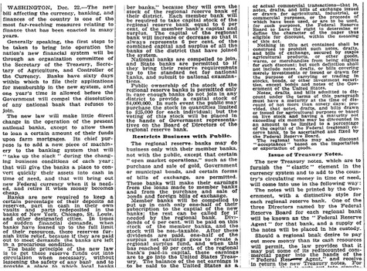](http://elainemeinelsupkis.typepad.com/.shared/image.html?/photos/uncategorized/2008/04/10/1913_fed_reserve_is_founded.jpg)

CLICK ON IMAGE TO ENLARGE!  
[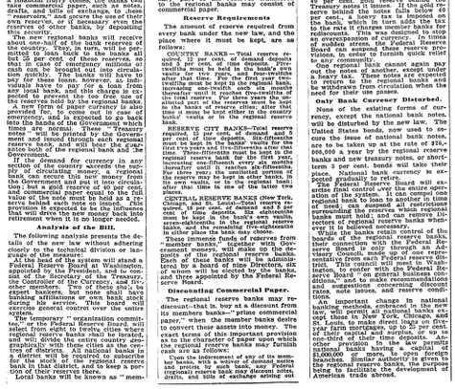](http://elainemeinelsupkis.typepad.com/.shared/image.html?/photos/uncategorized/2008/04/10/1913_fed_reserve_is_founded_part_2.jpg)

********************************************************

Note the 'Issue of Treasury Notes' here: this news story is all about the birth of the present system. To provide 'elasticity' to the lending system being set up, thanks to the failure of the 'greenback/silver' amendments, Congress was persuaded to put in a provision for the Treasury to 'sell notes' to the Federal Reserve!

'The notes will be printed by the Government, with the distinctive style for each regional reserve bank', says the article above. This was another compromise that was to set up a dual system whereby the manufacturing sectors could use the NY central bank while the south and west could circulate their own, lessor worth money. I have paper money from after this compromise. Each bill said where it originated. And the one that says, 'GOLD CERTIFICATE' was issued by the Federal Reserve bank of New York. The last of these were printed in 1930. When the banking system collapsed and nearly vanished.

After that, they kept the tradition of listing various regional Fed Reserve banks on paper notes but all of them said, 'For Paying Debts' not 'Gold Certificate' or 'Silver Certificate.'

Now for the funny money part of this old news story: 'Should the regional bank desire to pay out more money than its cash resources will permit, the law provides [ELAINE: a gigantic loophole] it may put some of its **rediscounted commercial paper into the hands of the "Federal Reserve Agent" and receive in return, the new Treasury notes.'** Isn't this very clever? Say 'hello' to eternal inflation! Of course, there was a brief period of deflation but this was due to the previous flood of funny money most of which was BLOWN UP in WWI. This funny money had to be paid off. And no one could. So it vanished and this caused a depression. Which was cured with a bigger money burning machine from hell: WWII.

On with this amazing news story: 'The Federal Reserve Agent will take commercial paper such as notes, drafts, and billos of exchange, to these "reservoirs" and secure the use fo their own reserves, or if necessary even the reserves of other banks, by depositing this security.'

My goodness! Talk about a wonderful money-making system! To keep it under control, they rigged it so that anyone needing more lending could drop off previous lending at the central bank headquarters and then tap into ALL the banks within the system to float MORE loans! The pious business about basing all this on gold was circumvented. Instead, the vast bulk of 'reserves' would be 'previous debts.' Anyone looking at a graph showing money inflation can clearly see how it took off instantly when the Federal Reserve was created.

Now watch the bouncing ball closely. The article details how this was supposed to still prevent rampant inflation via some restrictions: 'The new regional banks will receive about one-half of the bank reserves of the country. They, in turn, will be permitted to loan BACK to the banks [within the Reserve cluster system] all but 35% of these reserves, so that in the case of emergency millions of cash can be brought out into circulation quickly. **The banks will have to pay for these loans, however, as individuals have to pay for these loans as individuals have to pay for a loan from any local bank, and this charge is expected to prevent the too free use of the reserve held by the regional banks.** [ELAINE: HAHAHAHA]

This barn door was very hard to shut, wasn't it? Of course, the restrictions were relentlessly reduced in order to increase debt-making opportunities. Now we get to answer the question asked by Abelian concerning the Treasury and the Fed and how they interact. Back to the news story from 1913: 'A NEW FORM OF PAPER CURRENCY is also provided for to come out in case of an EMERGENCY, [ELAINE: wars, of course.] and is expected to go back into the hands of the Government which times are normal. [ELAINE: i.e.=NEVER.] These "Treasury notes" will be printed by the Government and issued through each regional reserve bank, and will bear the guarantee BOTH of the regional bank AND THE GOVERNMENT.'

Aha! There it is! We know that regional banks fail. They can't help but over lend. They can't help but give sweetheart loans to politically connected people who grease government representative's palms. So the ONLY guarantor is the majestic US government. Now, what drives governments into overspending and huge debts?

WARS! Of course. Since the dawn of time. Many a nasty war was launched based on loans from international bankers. They love doing this. For they can collect from all the rents and taxes on an entire nation, not mere individuals. And when Kings and Emperors refuse to pay, they lose their wars or they loot their own people to pay for attacking their BANKER'S national headquarters. If the bankers are in Lombardy, for example, the bankrupt emperors loot the Jews and then hire Swiss mercenaries to kill the bankers in Lombardy, just for one major historical example.

Note also how the Federal Reserve was born: they did NOT print the money. They gingerly had their hands off of this process. They printed the circulars, the greenbacks. But NOT THE DEBT TO THE GOVERNMENT. The government did this for them. The Treasury prints up Federal Reserve IOUs for the Fed itself. While the Fed then uses these DEBTS to print their own currency which we call 'dollars'. I hope this is all clear. This 'hands-off' methodology was set up to PUT THE NATION INTO HOCK for any lending done by the regional banks! There had to be some connection. Like a blood sucking parasite, the Federal Reserve had to tap into the wealth of the nation to back their money since gold was going to decline as a percentage of value. And trust me, they didn't wait even 5 years to launch this mess!

Now, see, our ancestors were smart. They knew this opened the barn door to national bankruptcy. So they put in more provisions to prevent this possibility: 'If the demand for currency in any section of the country exceeds the supply of the circulating money, a regional bank can secure this new money FROM THE GOVERNMENT and put it into circulation; but a GOLD RESERVE OF 40% AND COMMERCIAL PAPER equal to the FULL VALUE of the note must be HELD AS A RESERVE behind EACH NOTE ISSUED [using the government's lending to the Fed banks!]. This provision is expected to be the influence that will DRIVE THE NEW MONEY BACK INTO RETIREMENT when it is no longer needed.'

HAHAHA. There it is! The same restrictions and same open barn door. Of course, the ratio of gold held to commercial paper was ruthlessly reduced to O% in the case of gold and 'of unknown value' in the case of commercial paper! The whole Basel II demands that all commercial paper be valued in the markets and all being held by the banks as assets upon which they may grab up Treasuries and issue more loans, must be realistic and not fake. Like we saw just the other day with Goldman Sachs openly lying about their Level III commercial paper.

And since when does the Fed, our bankers or ANYONE retire A PENNY????? The penny isn't worth the cheapest metal and they keep talking about eliminating it. This essentially will be removing one digit from our finances. Then they will totally remove it, of course. Adding zeros is easy. South American governments do this all the time!

Now for more fun: 'At the head of the new Federal Reserve system will stand a Federal Reserve Board at Washington, appointed by the President, and to consist of the Secretary of the Treasury, the Controller of the Treasury [ELAINE: the OCC is what the Fed wants dearly to take over in a coup this month!] and 5 other members [ELAINE: more of them today than back then, they grossly outnumber the government guys!]. Two of these shall be expert bankers, but none shall have banking affiliations or own bank stock during his service...' Further on in the story, the reserves are set: country banks must hole 12%, city banks hold 15% and the Central banks of the Fed itself, 18% in reserves. I like to joke that our Federal Reserves is neither Federal nor holds reserves. Alas, these optimistic numbers back then show how far things have fallen.

Now for more meat and potatoes in this good news story: **'The regional reserve banks may REDISCOUNT---that is buy at a discount from its members banks--"prime commercial paper," when the member banks desire to CONVERT THESE ASSETS INTO MONEY.'** There is a long explanation as to what constituted 'prime commercial paper.' If a regional Fed bank overruns too much thanks to the open barn doors, there would be a HEAVY TAX that will crush such wild granting of easy money and many loans! Only in times of sudden stress can this be overturned. Like in time of WARS.

Here is yet another key element set up in 1913: 'None of the existing forms of currency, except the national bank notes, will be disturbed by the new law. The United States bonds, now used to secure the issue of national bank notes, are to be taken up at the rate of $25,000,000 a year by the regional reserve banks and the new treasury notes, or short term 3% BONDS will take their place.'

This is where the scheme to get the United States Government to lend to the Federal Reserve at 3%. The Treasury was to provide SHORT TERM bonds and 3% back in 1913 was a high rate. This was supposed to discourage the Federal Reserve officers from lending like crazy with no limits. They were supposed to be PUNISHED by this system. And if they needed even more, a TAX was to be levied upon these Treasury bonds. All of this, the news paper reporter notes, was to '...facilitate the development of AMERICAN TRADE ABROAD.'

So here we come full circle: American trade has utterly crashed through the floor and is falling rapidly. Namely, compared to IMPORTS, it is doing hideously. Each year is worse than the year before. Even with reducing the dollar's worth by 95%, the trade situation gets worse and worse. We see in this story the other barn door that opened here: the Fed and the Government of the United States have this circular relationship. If the US government overspends and issues more and more Treasury bonds to cover the excess spending, this flows to the Federal Reserve and worse, our own government NOW PAYS THE FEDERAL RESERVE INTEREST ON THIS!!!!

OH MY GOD FROM HELL AND BACK! HAHAHA. Sigh.

This is why Greenspan smiled when Bush cut taxes. The Fed suddenly found itself facing annihilation when the US government began to pay back these Treasury bonds! Instead, thanks to this wide open barn door, the US government has run up nearly $10 trillion in debts to the Federal Reserve which uses this huge overflow to back a huge growth in US commercial and real estate debts! See? Isn't this easy? History is a great way to look at modern things.

And what drove us off the cliff? WARS! Unlike social services, wars usually, in the case of our empire, are fought on someone else's turf. So we can burn up endless Treasuries this way. Starting with WWI: the US Fed funded that war as well as other sources. The war would have ended much faster except for Fed funding. All the charts show how money creation shot through the roof starting in 1915, a mere 2 years after creating the Federal Reserve. Instead of Congress voting to fund wars via things like the Louisiana Purchase, now the Federal Reserve could directly hand out war funds with the OK of the President. The Imperial Presidency was born. Instead of high taxes constraining war making, the sky was now the limit. All wars could be fought forever until 'victory' no matter how expensive. Indeed, the more expensive, the better.

And after WWII, we dealt with the possibility of economic contraction due to cessation of war spending by launching the Cold War. That still kept us in the doldrums so a new hot war was born: the Korean war then the much worse, as far as spending was concerned, Vietnam War. Even as inflation raged and the currency was openly debased, this went on and on.

When that war ended badly, we had raging inflation, of course, along with economic stagnation. This was fixed by more proxy wars in Central and South America as well as the Holy Land. And expansion of the US empire and confrontations with Russia requiring more spending on missile systems. Then Russia collapsed. The US went into recession so we started wars with Iraq and now, are starting one with Iran! All, to keep things rolling.

Alas, also with China: this is WWIII, the Ultimate Solution to Federal Reserve funny money making messes!

Now on to a few more items to prove my points, an article from during WWI:

[July 15, 1917  
State Banks and Reserve System. Loan Certificates Interchangeable.](http://query.nytimes.com/gst/abstract.html?res=9905E6D9133BE03ABC4D52DFB166838C609EDE)

[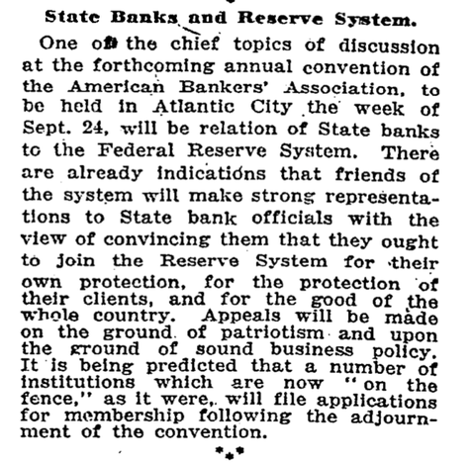](http://elainemeinelsupkis.typepad.com/.shared/image.html?/photos/uncategorized/2008/04/10/picture_21.png)  
[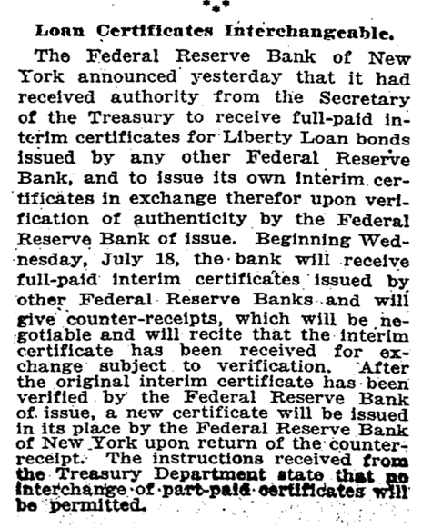](http://elainemeinelsupkis.typepad.com/.shared/image.html?/photos/uncategorized/2008/04/10/picture_22.png)

********************************************************

In a nutshell: the greedy Fed demanded to take over the issuing of war bonds! HAHAHA. And there it is! Right off the old bat. They blew that pitch right over the fence, didn't they? Home run.

[Here is another web page that talks about all this, Money Masters:](http://www.themoneymasters.com/faqs.htm)

*If you are a little uncomfortable with “your” Fed having “private aspects,” you are not alone. Notice also the contradiction with the other NY Fed quote above, which claims the citizens of the US own the Fed – here it claims no one owns it (same website). The truth and the law is that the member banks own and control all 12 Federal Reserve Banks. Another interesting doublespeak quote from the NY Fed website: Therefore, the Federal Reserve can be more accurately described as "independent within the government.” A little independence is a good thing, unless that independence is in reality virtually total and the entity involved controls the nation’s money and economy. Think about it: if the Fed is independent from the government that created it, then who controls it – it has no brain of its own – it is not a person. If it is not controlled by our government, then by whom?*

This web page tries to encapsulate how the system works. It doesn't do the whole history, of course. We can see from the newspaper articles, the whole smear was set into motion with all sorts of reservations and fears and restrictions. But nearly instantly, these were blown out of the water in order to fund 'The War To End All Wars.' Of course, this only spawned ever-bigger wars. The End Of All Wars will the [be] the Apocalypse.

*The Board of Governors of the System consists of 7 members, one appointed every two years (one term begins every two years, on February 1 of even-numbered years, a full year after inauguration day) by the President and confirmed by the Senate for 14 year terms. Wow…those are really long terms. Why? Let’s see: if a new President comes into office pledged to reform the Fed, end its independence from effective government oversight, throw the rascals out and replace them with his own appointees, he had better be very patient, as he can only replace one member every two years. So in his four year term (10 years less than Fed Governors’ terms) he can replace only two of the 7 members. Of course, he had better be able to sustain the ire of the remaining Governors (almost all connected to financial institutions indirectly in various academic and think-tank institutions financed by banks and bank grants or loans, or which they hope to join in revolving door relationships after their single terms are up), who can run the economy up, down or sideways, in the interim.*

*But assuming the President can sustain the fight with the Fed, its bank-PAC financed cheerleaders in the Senate, voters upset over a suddenly sinking economy, the banks who control the Fed and the media giants they also own, then all this brave but foolhardy President has to do is get elected to a second term, and hang on long enough to appoint two more Board members. Thus, assuming all of this goes well, in the span of seven years (a glacial pace in American politics), near the end of his second term, he can finally begin some reform – if he manages to get his four appointees confirmed, is still in office and has any allies left – even in his own party. We think the prefixed word quasi-governmental is a good one, if you understand quasi- to mean pseudo.*

I included this to show how the investors within the Federal Reserve system had their pretty little coup. They slowly rigged the system so they could overrule Presidents as well as Congress. They then coddled and prepped their team using 'think tanks' and places like Yale University. This system has no input from outsiders. There is now an army of people on the outside yelling about the very things our ancestors screamed about. The 'hard money' people are up in arms over how totally the Federal Reserve has hijacked our currency, our banking system and our finances. We see nothing but future disasters coming from this crazy 'central bank' that is NOT beholden to the American People but to bankers! Many of whom are in cahoots with FOREIGN POWERS and alien rich people like the Saudi Royal Family, just for example.

Since NO ONE in the Fed represents the People of America, our trade deficit mushrooms, our Federal spending mushrooms and bubbles billow upwards and make messy pops driving us all into penury and serfdom. The joys of 'easy money' are soon turned tears as the shackles of slavery are forged!

From the Money Masters:

*Question: How does the Fed “create” money out of nothing?*

*Answer: It is a four-step process. But first a word on bonds. Bonds are simply promises to pay — or government IOUs. People buy bonds to get a secure rate of interest. At the end of the term of the bond, the government repays the principal, plus interest (if not paid periodically), and the bond is destroyed. There are trillions of dollars worth of these bonds at present. Now here is the Fed moneymaking process:*

*Step 1. The Fed Open Market Committee approves the purchase of U.S. Bonds on the open market.*

*Step 2. The bonds are purchased by the New York Fed Bank from whomever is offering them for sale on the open market.*

*Step 3. The Fed pays for the bonds with electronic credits to the seller’s bank, which in turn credits the seller’s bank account. These credits are based on nothing tangible. The Fed just creates them.*

*Step 4. The banks use these deposits as reserves. Most banks may loan out ten times (10x) the amount of their reserves to new borrowers, all at interest.*

*In this way, a Fed purchase of, say a million dollars worth of bonds, gets turned into over 10 million dollars in bank deposits. The Fed, in effect, creates 10% of this totally new money and the banks create the other 90%.*

*This also explains why the Fed consistently holds about 10% of the total US Treasury bonds. It had to buy those (with accounts or Fed notes the Fed simply created) from the public in order to provide the base for the rest of the money the private banks then get to create, most of which eventually winds up being used to purchase Treasury bonds, thus supplying Congress with the borrowed money to pay for its expenditures.*

*Due to a number of important exceptions to the 10% reserve ratio, some loans require less than 10% reserves, and many no (0%) reserves, making it possible for banks to create many times more than ten times the money they have in “reserve”. Due to these exceptions from the 10% reserve requirement, the Fed creates only a little under 2% of the total US money supply, while private banks create the other 98%.*

*To reduce the amount of money in the economy, the process is just reversed — the Fed sells bonds to the public, and money flows out of the purchaser’s local bank. Loans must be reduced by ten times the amount of the sale. So a Fed sale of a million dollars in bonds, results in 10 million dollars less money in the economy.*

OK: note at how warped this is compared to the news story from 1913. It is obvious, the present opaque system has been set into gear to hide the truth and hide the losses of sovereignty embedded within the creation of the Fed. Remember, our ancestors who read the New York Times back then were suspicious and canny at the same time. But they needed to fix depressions and crashes like the 1907 mess. So they wanted to be saved. And walked into the Cave of Death for salvation.

Note also the degradation of the reserve ratios. This is now being reduced to 0% as I write this story.

[Here is the Federal Reserve's explanations about how Treasury Auctions work:](http://www.newyorkfed.org/aboutthefed/fedpoint/fed41.html)

*The U.S. Treasury Department regularly borrows to finance the Federal Government's debt. From 1980 to 2006, the public debt of the United States grew from $930 billion to $8.68 trillion. Approximately one-half of that debt is held in Treasury bills, notes, and bonds, or "treasuries." The Treasury Department sells these securities at auctions held at the Federal Reserve Bank of New York, and the Bureau of Public Debt (BPD) in Washington, D.C. The rest of the debt is held mostly in federal and federally sponsored agency securities and U.S. Savings Bonds, and is not sold through the auction process.*

*Most treasuries are bought at auction by the "primary" dealers—financial institutions that are active in buying and selling U.S. government securities and have established business relationships with the New York Fed.*

*A much smaller volume of securities is purchased by individual investors who buy them directly from the Treasury Department at auction instead of from banks or brokers in the secondary market. Investors who purchase securities directly from the Treasury avoid the commission fees associated with purchases through a dealer.*

These TRAITORS sold these bonds to whom? How about Japan and China, the two biggest holders, holding over a trillion in these things! And then there are the oil pumping nations. They hold many more hundreds of billions. And then the pirates: they hold billions and billions in offshore accounts or in London! Look at this mess! We are OWNED BY THE WORST OF THE WORST! And we pretend we are a strong nation? Bah.

[Remarks by Governor Ben S. Bernanke](http://www.federalreserve.gov/BOARDDOCS/SPEECHES/2002/20021121/default.htm)

[Before the National Economists Club, Washington, D.C.  
November 21, 2002](http://www.federalreserve.gov/BOARDDOCS/SPEECHES/2002/20021121/default.htm)

*Deflation: Making Sure "It" Doesn't Happen Here   
Since World War II, inflation--the apparently inexorable rise in the prices of goods and services--has been the bane of central bankers. Economists of various stripes have argued that inflation is the inevitable result of (pick your favorite) the abandonment of metallic monetary standards, a lack of fiscal discipline, shocks to the price of oil and other commodities, struggles over the distribution of income, excessive money creation, self-confirming inflation expectations, an "inflation bias" in the policies of central banks, and still others. Despite widespread "inflation pessimism," however, during the 1980s and 1990s most industrial-country central banks were able to cage, if not entirely tame, the inflation dragon. Although a number of factors converged to make this happy outcome possible, an essential element was the heightened understanding by central bankers and, equally as important, by political leaders and the public at large of the very high costs of allowing the economy to stray too far from price stability.*

*With inflation rates now quite low in the United States, however, some have expressed concern that we may soon face a new problem--the danger of deflation, or falling prices. That this concern is not purely hypothetical is brought home to us whenever we read newspaper reports about Japan, where what seems to be a relatively moderate deflation--a decline in consumer prices of about 1 percent per year--has been associated with years of painfully slow growth, rising joblessness, and apparently intractable financial problems in the banking and corporate sectors. While it is difficult to sort out cause from effect, the consensus view is that deflation has been an important negative factor in the Japanese slump.*

In 2002, I didn't see any deflation. I saw climbing oil prices. Higher electrical bills. Higher medical insurance costs. Higher schooling costs. The ONLY things going down were IMPORTED PRODUCTS FROM ASIA. And they flooded in. Like crazy. All Bernanke and Greenspan had to do was this: demand tariffs and barriers! This would stop deflation in its tracks.

But they did the OPPOSITE. So the flood of imports increased. They increased the ability to borrow money so a gigantic money lending frenzy blew apart our entire banking and economic systems. The cheaper the loans, the swifter our industries moved to Asia, the more Asia held our dollars in mushrooming FOREX reserve accounts. And the worse things got for our basic economy. We built houses by tearing down factories! Isn't that insane? And no one could stop the Fed, either. Even as inflation began to fly to the skies, all these bastards did was LIE about inflation! How simple is that?

Bernanke:

*Although deflation and the zero bound on nominal interest rates create a significant problem for those seeking to borrow, they impose an even greater burden on households and firms that had accumulated substantial debt before the onset of the deflation. This burden arises because, even if debtors are able to refinance their existing obligations at low nominal interest rates, with prices falling they must still repay the principal in dollars of increasing (perhaps rapidly increasing) real value. When William Jennings Bryan made his famous "cross of gold" speech in his 1896 presidential campaign, he was speaking on behalf of heavily mortgaged farmers whose debt burdens were growing ever larger in real terms, the result of a sustained deflation that followed America's post-Civil-War return to the gold standard.4 The financial distress of debtors can, in turn, increase the fragility of the nation's financial system--for example, by leading to a rapid increase in the share of bank loans that are delinquent or in default. Japan in recent years has certainly faced the problem of "debt-deflation"--the deflation-induced, ever-increasing real value of debts. Closer to home, massive financial problems, including defaults, bankruptcies, and bank failures, were endemic in America's worst encounter with deflation, in the years 1930-33--a period in which (as I mentioned) the U.S. price level fell about 10 percent per year.*

News flash to Bernanke: the dollar is dropping in value, not rising. We can't even afford cheap Asian goods. Inflation is raging in Asia thanks to the US and the pirate community making funny money like crazy via the Federal Reserve and the Central Bank of Japan. In today's news, China's FOREX reserves are over $1.65 trillion and climbing. The Derivative Beast grew from $1 in 1974 to $550 trillion today! Everything is shooting out of control.

Well, another bitter history lesson! Class dismissed.